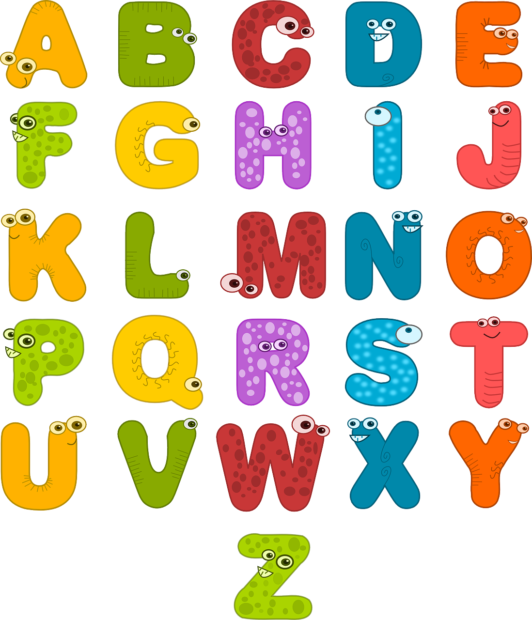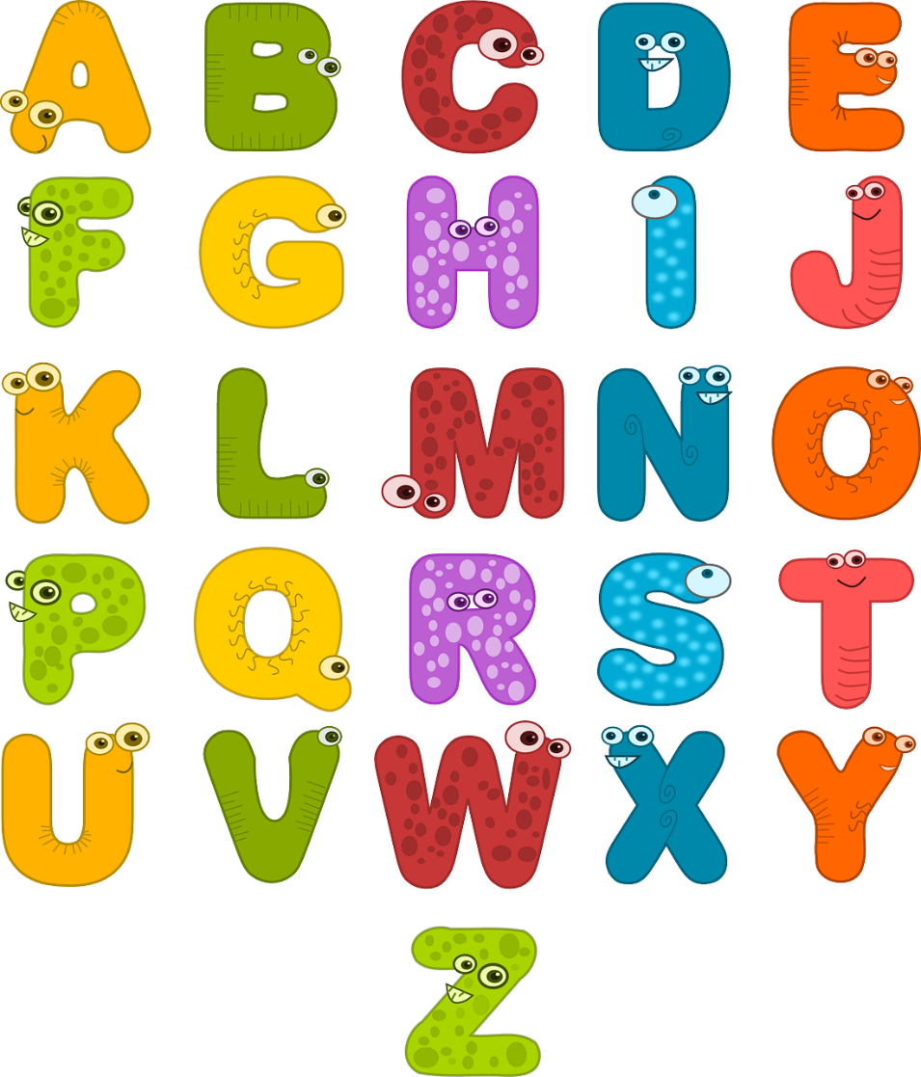

|  |  |  |  |  |  |  |
| --- | --- | --- | --- | --- | --- | --- |
| Std. | Zeit | Montag | Dienstag | Mittwoch | Donnerstag | Freitag |
| 1. | 07:45 - 08:35 | R | DLS | DLS | R | DLS |
| 2. | 08:35 - 09:25 | DLS | M | BS | DLS | M |
| 3. | 09:45 – 10:35 | M | DLS | M | BS | DLS |
| 4. | 10:35 – 11:25 | SU | ME | BE | WE | SU |
|  |  |  |  |  |  |  |
|  |  |  |  |  |  |  |
|  |  |  |  |  |  |  |

STUNDENPLAN – 1. Klasse